**Software Requirements Specification**

**(SRS) Document**

# GENU (Great Eats Near U)

**05/20/2024**

**Version 1**

**Mogoi Matongo, Ashirvad Khanal, Ashish Khanal.**

**Project Link**

[**https://github.com/akhanal222/CSC-340-PROJECT**](https://github.com/akhanal222/CSC-340-PROJECT)

Table of Contents

GENU (Great Eats Near U) 0

1. Project General Description 3

2. Project Overview 4

3. Product Features 5

4. Functional Requirements 6

4.1 Functional Requirements (Customer) Ashirvad Khanal 6

4.2 Functional Requirements (Restaurant Owners) AshishKhanal 7

4.3 Functional Requirements (Administrators) Mogoi Matongo 8

5. Non-Functional Requirements 9

6. Scenarios (Three scenarios for each Costumer, owner and admin) 10

6.1 Customers 10

6.2 Owners 11

6.3 System Administration 12

7.Design Document 13

7.1 Use-case Model 13

7.2 State Machine Diagram 14

7.2.1 User - Ashirvad Khanal 14

7.2.2 Restaurant Owner - Ashish Khanal 15

7.2.3 Admin - Mogoi Matongo 16

7.3 Database Schema 17

7.4 Software Architecture - MVC 18

8. Scenarios With Screenshots 19

8.1 Customer Scenario: Making a Reservation 19

8.2 Owner Scenario: Responding to a Review 21

8.3 System Administration Scenario: Managing User Access 24

# Project General Description

The Great Eats Near U (GENU) web application aims to connect users to the nearest restaurants with better dining options. This platform enables users to find nearby restaurants, make reservations, and share reviews without hassles. Also, this application is user-friendly and mainly focused on providing users with the best quality services possible in nearby areas.

This application gives restaurant owners a platform to promote and enhance their business experiences by improving sales and customer flow. It allows restaurant owners to manage their restaurant’s profile, handle reservations, and respond to customer reviews. Administrators take care of user management, and content upgrades, and moderate and maintain the balanced experience for all users.

This application also gives the users information about the restaurants like addresses, and contact information, sends email notifications, and allows users to share their thoughts as a review online. The main goal of this Great Eats Near U web application is to find costumes and connect them to the place to eat with fun and easy experiences with fewer hassles.

# ­­Project Overview

The Great Eats Near U (GENU) web application aims to connect users to the nearest restaurants with better dining options. This platform enables users to find nearby restaurants, make reservations, and share reviews without hassles. Also, this application is user-friendly and mainly focused on providing users with the best quality services possible in nearby areas. This application gives restaurant owners a platform to promote and enhance their business experiences by improving sales and customer flow. It allows restaurant owners to manage their restaurant’s profile, handle reservations, and respond to customer reviews. Administrators take care of user management, and content upgrades, and moderate and maintain the balanced experience for all users.

This application also gives the users information about the restaurants like addresses, and contact information, sends email notifications, and allows users to share their thoughts as a review online. The main goal of this Great Eats Near U web application is to find costumes and connect them to the place to eat with fun and easy experiences with fewer hassles

# Product Features

The web-based application GENU (Great Eats Near U) is designed to revolutionize the way users choose the restaurant they like. Below are the key features and functions that define the essence of the application:

Restaurant Search⇒ Our app will use an advanced filter algorithm, so users can find the restaurant based on their choice of filter the user can be able to choose based on location, type of restaurant, rating, etc. so using this we will be able to assist users to look through restaurants very quickly based on their interests.

Reservation Management⇒ Our app will allow the user to search for the restaurant based on their choice and book the tables online with just a few clicks on our web app within minutes. The app will let customers look through the time slots available and the preferred restaurant based on the area and type of restaurant like French, Chinese, Japanese, Italian, Indian, etc., and review the restaurant.

Review and Rating System⇒ Our app will allow users to leave a review and rate the quality of the restaurant they visited. Using the review system other customers will be able to see the quality of the food and the efficiency of services. Review for the customers can help the restaurant to improve its service experience so it can attract other customers.

Notifications and Reminders⇒ Our app will send notifications to the customs through an email with a confirmation number of their reservation. This will ensure that the customer will have a seamless experience when they arrive at the restaurant.

Restaurant Owner Tools: Our app will allow the owner of the restaurant to manage their restaurant page add a picture, reply to the user review, etc. It will help the restaurant to build a positive reputation and strengthen its relationship with its customers.

# Functional Requirements

## 4.1 Functional Requirements (Customer) Ashirvad Khanal

**-** FR0⇒The app will allow customers to create a profile.

* FR1⇒The app will allow the customers to modify their profile.
* FR2⇒ The app will allow customers to filter their choice of restaurants.
* FR3⇒The app will allow customers to search for restaurants.
* FR4⇒ The app will allow customers to view their Reservations.
* FR5⇒ The app will allow customers to make reservations at restaurants.
* FR6⇒ The app will allow customers to leave reviews for restaurants.
* FR 7⇒ Accounts will be protected by login pages with passwords.
* FR8⇒ The app will send email notifications for reservation confirmations and reminders.

## 4.2 Functional Requirements (Restaurant Owners) AshishKhanal

* FR0⇒The app will allow restaurant Owners to create a profile.
* FR1⇒The app will allow restaurant Owners to modify their restaurant profile.
* FR 2⇒ Accounts will be protected by login pages with passwords.
* FR3⇒ The app will send email notifications of the reservation time and date to the restaurant.
* FR4⇒ The restaurant will be able to respond to customer reviews.

## 

## 4.3 Functional Requirements (Administrators) Mogoi Matongo

* FR0⇒The app will allow administrators to create, edit, and delete a profile of restaurant owners and customers.
* FR1⇒ The app will allow administrators to monitor and moderate content in-app including reviews and profiles.
* FR 2⇒ The app will give administrators authority to handle content moderation actions.
* FR3⇒ The app will provide administrators the ability to manage system settings and ensure the system runs smoothly.

# 5. Non-Functional Requirements

-NFR 0⇒ The system should be able to process and confirm reservations within 10 seconds in the Web App.

-NFR 1⇒ The system should be able to generate the nearby restaurant within 10 seconds. -NFR -NFR 12⇒ The system will be able to send a confirmation email to the customer within 1-5 min and send them a reminder 15 min before the reservation time.

# 6. Scenarios (Three scenarios for each Costumer, owner and admin)

## 6.1 Customers

Create/Modify Customer Profile

**Initial Assumption:** The customer has access to the GENU web app, is logged in, and is on the profile page.

**Normal:**

* customer enters or updates their personal details, such as name, contact information, and preferences for cuisine.
* The customer saves the profile.

**What Can Go Wrong:** The customer might enter incomplete or invalid information, causing an error message to appear. The system should prompt the customer to correct the information. **Other Activities:** The customer can choose to upload a profile picture or link their social media accounts.

**System State on Completion:** The customer's profile is updated with the new information and preferences.

## 6.2 Owners

Respond to Customer Reviews

**Initial Assumption:** The restaurant has received reviews from customers, and the owner is logged in.

**Normal:**

* navigates to the review section.
* reads a customer review.
* writes and submits a response to the review.

**What Can Go Wrong:** The response might not be submitted if the internet connection is lost.

The system should save the response draft locally until the connection is restored.

**Other Activities:** The owner can mark reviews that need follow-up actions.

**System State on Completion:** The response is posted and becomes visible alongside the original review, showing customer engagement.

## 6.3 System Administration

Manage User Access

**Initial Assumption:** The Sysadmin is logged into the GENU web application.

**Normal:**

* navigates to the user management section
* views the list of users, including customers and restaurant owners
* updates access rights, such as granting or revoking permissions

**What Can Go Wrong:** Incorrect permissions might be assigned. The system should allow for quick corrections and log all changes for review.

**Other Activities:** The Sysadmin can send notifications to users about access changes. **System State on Completion:** User access is successfully updated, ensuring proper usage of the system.

# 7.Design Document

## Use-case Model

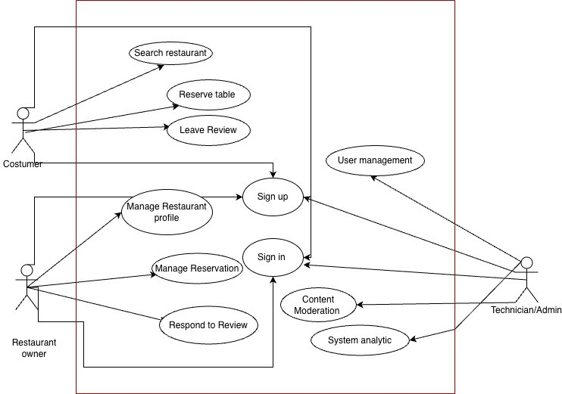

## State Machine Diagram

### User - Ashirvad Khanal

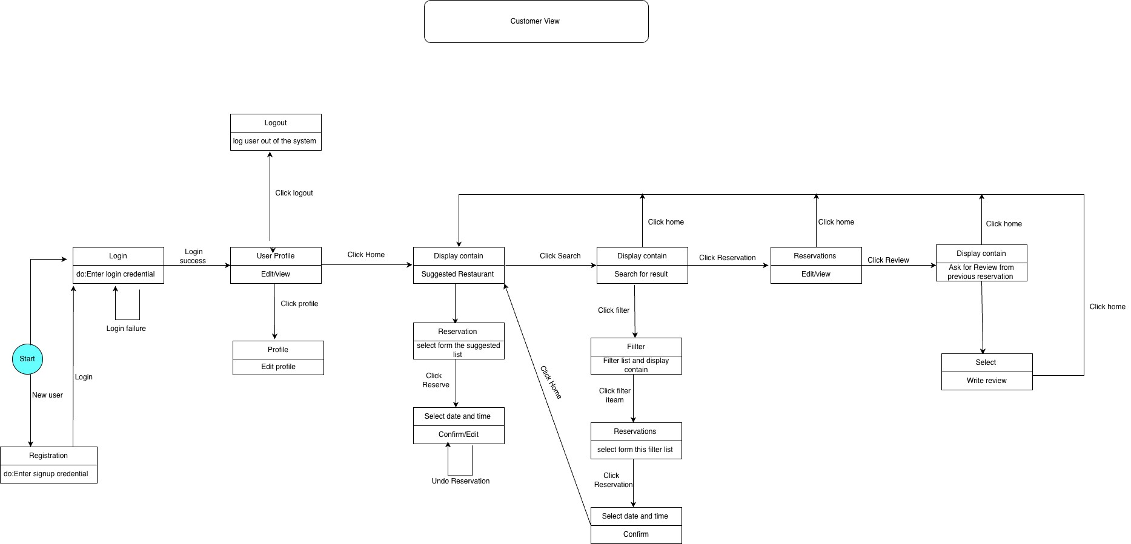

### 7.2.2 Restaurant Owner - Ashish Khanal

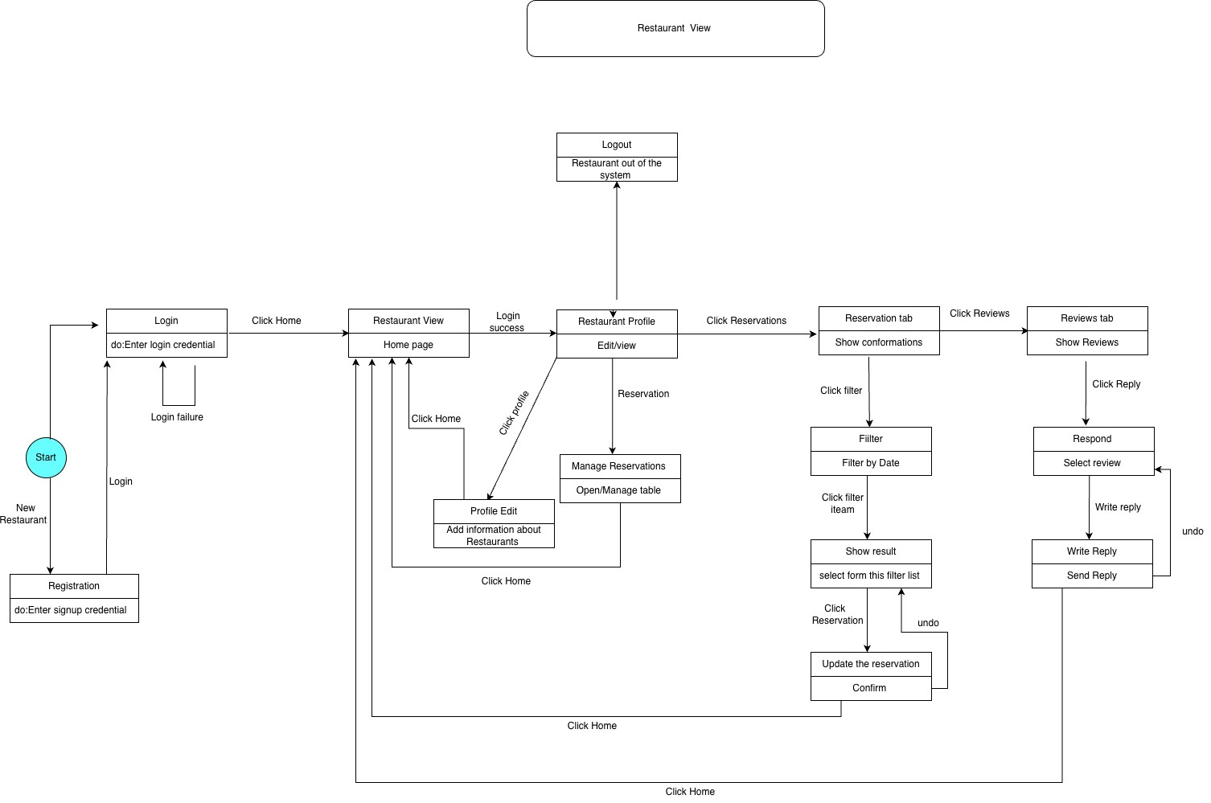

### Admin - Mogoi Matongo

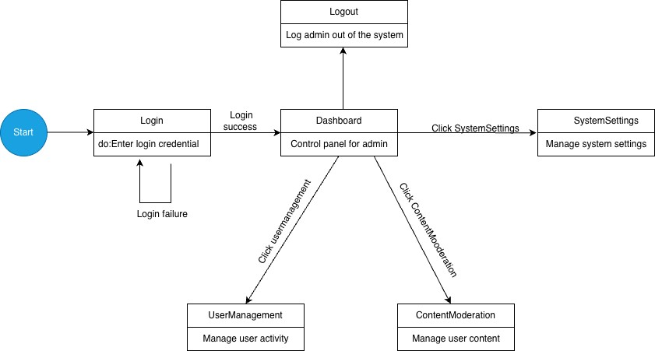

## 7.3 Database Schema

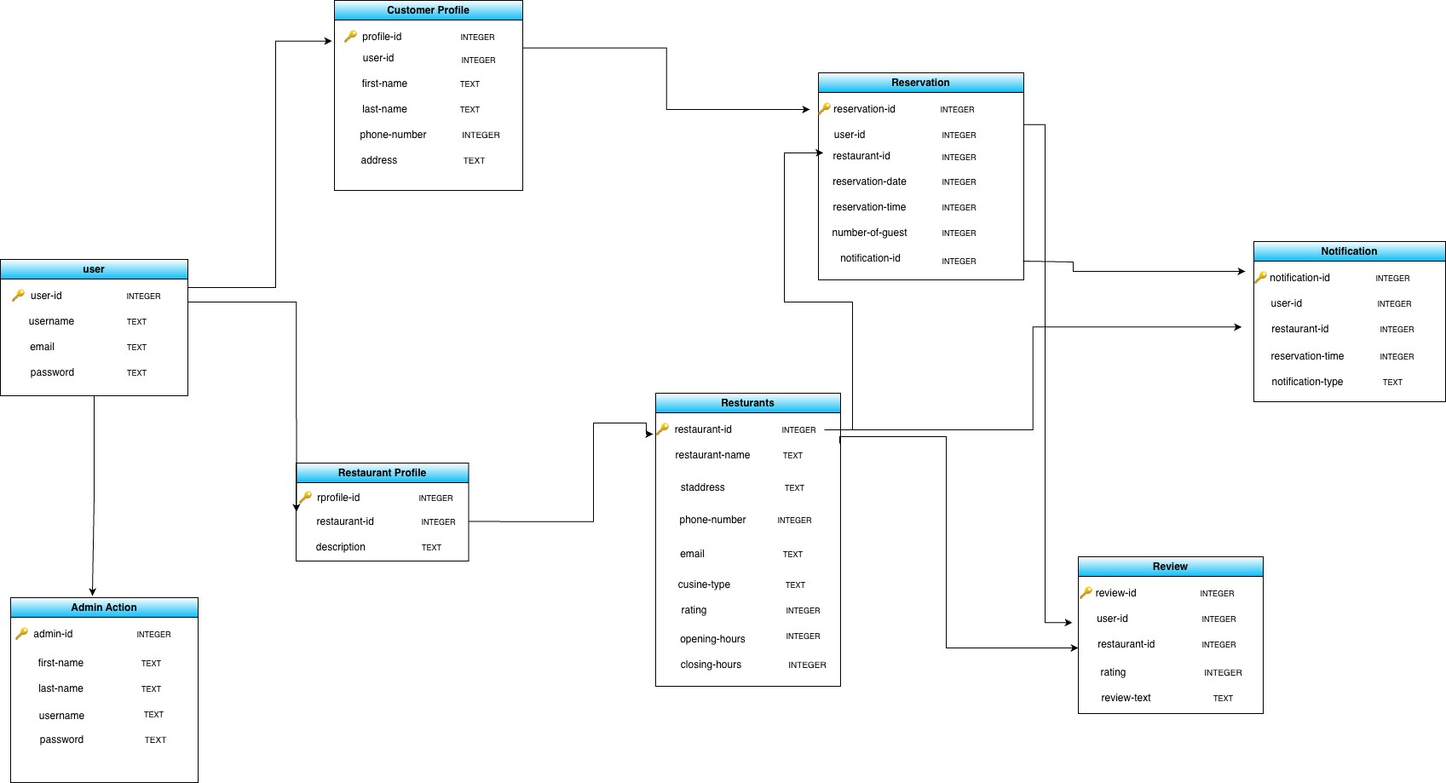

## 7.4 Software Architecture - MVC

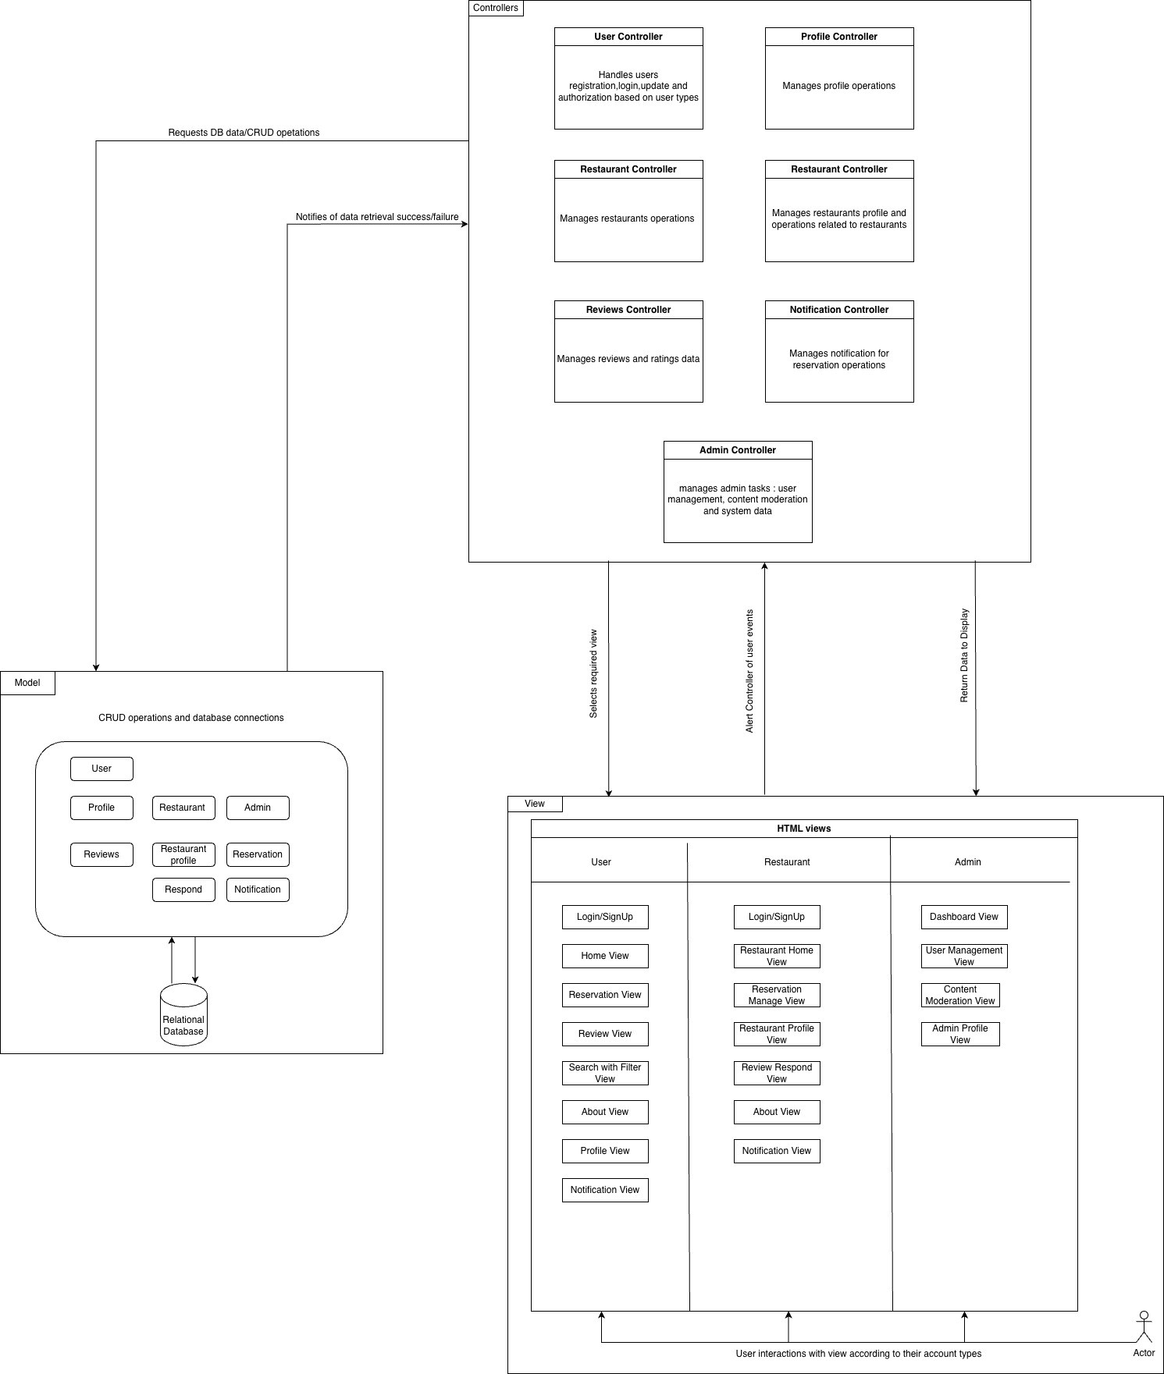

# 8. Scenarios With Screenshots

## 8.1 Customer Scenario: Making a Reservation

**Assumption:** The customer is logged in and on the restaurant search page.

**Steps:**

1. Customer uses the filter to search for a restaurant.
2. Customer selects a restaurant from the search results.
3. Customer views the restaurant's details and selects "Make a Reservation."
4. Customer chooses a date and time for the reservation.
5. Customer confirms the reservation.

Figure 1: Search for a Restaurant

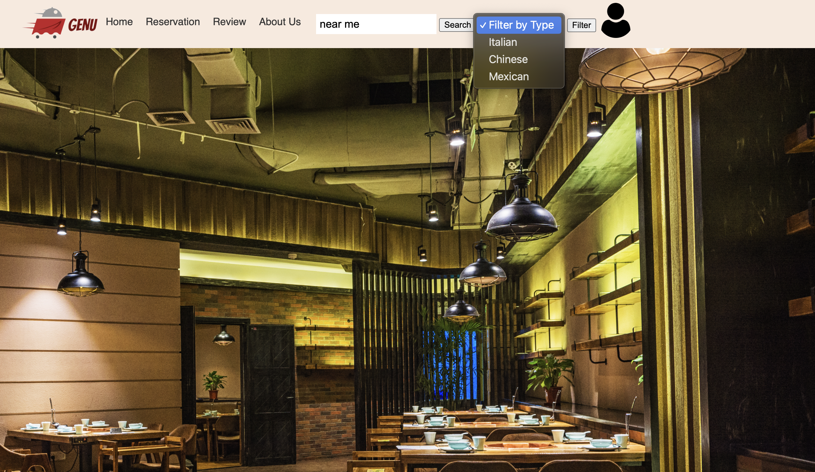

Figure 2: Restaurant Details

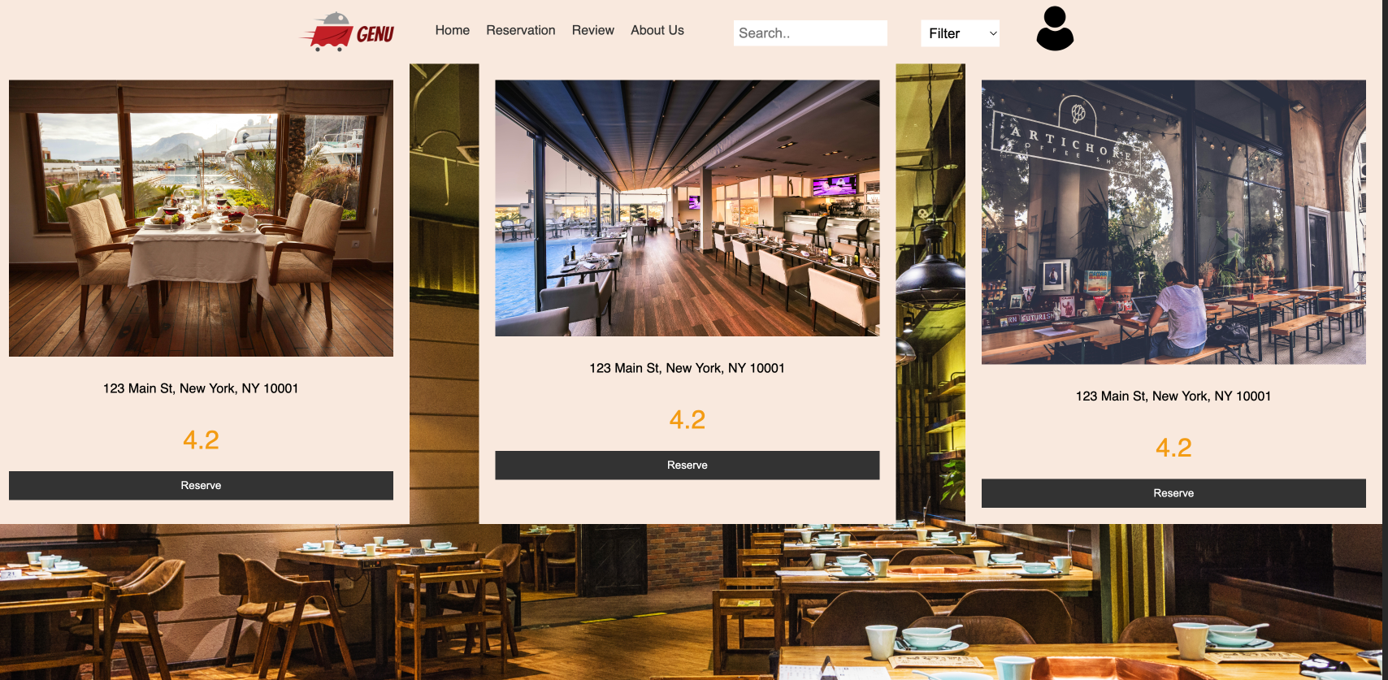

Figure 3: Make a Reservation

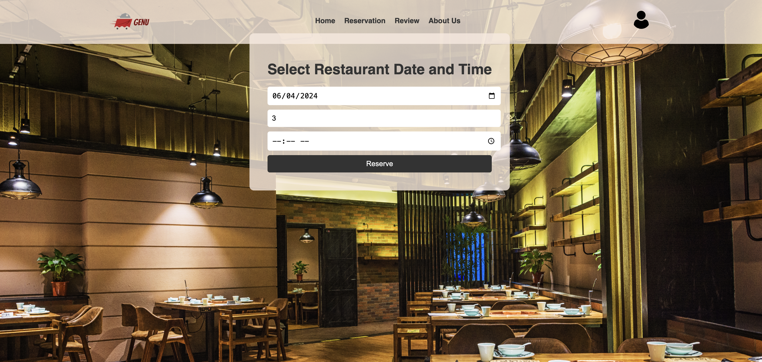

## 8.2 Owner Scenario: Responding to a Review

**Assumption:** The owner is logged in and on the review section of their restaurant profile.

**Steps:**

1. Owner navigates to the review section.
2. Owner reads a customer review.
3. Owner writes a response and submits it.

Figure 1: Customer Review Tab

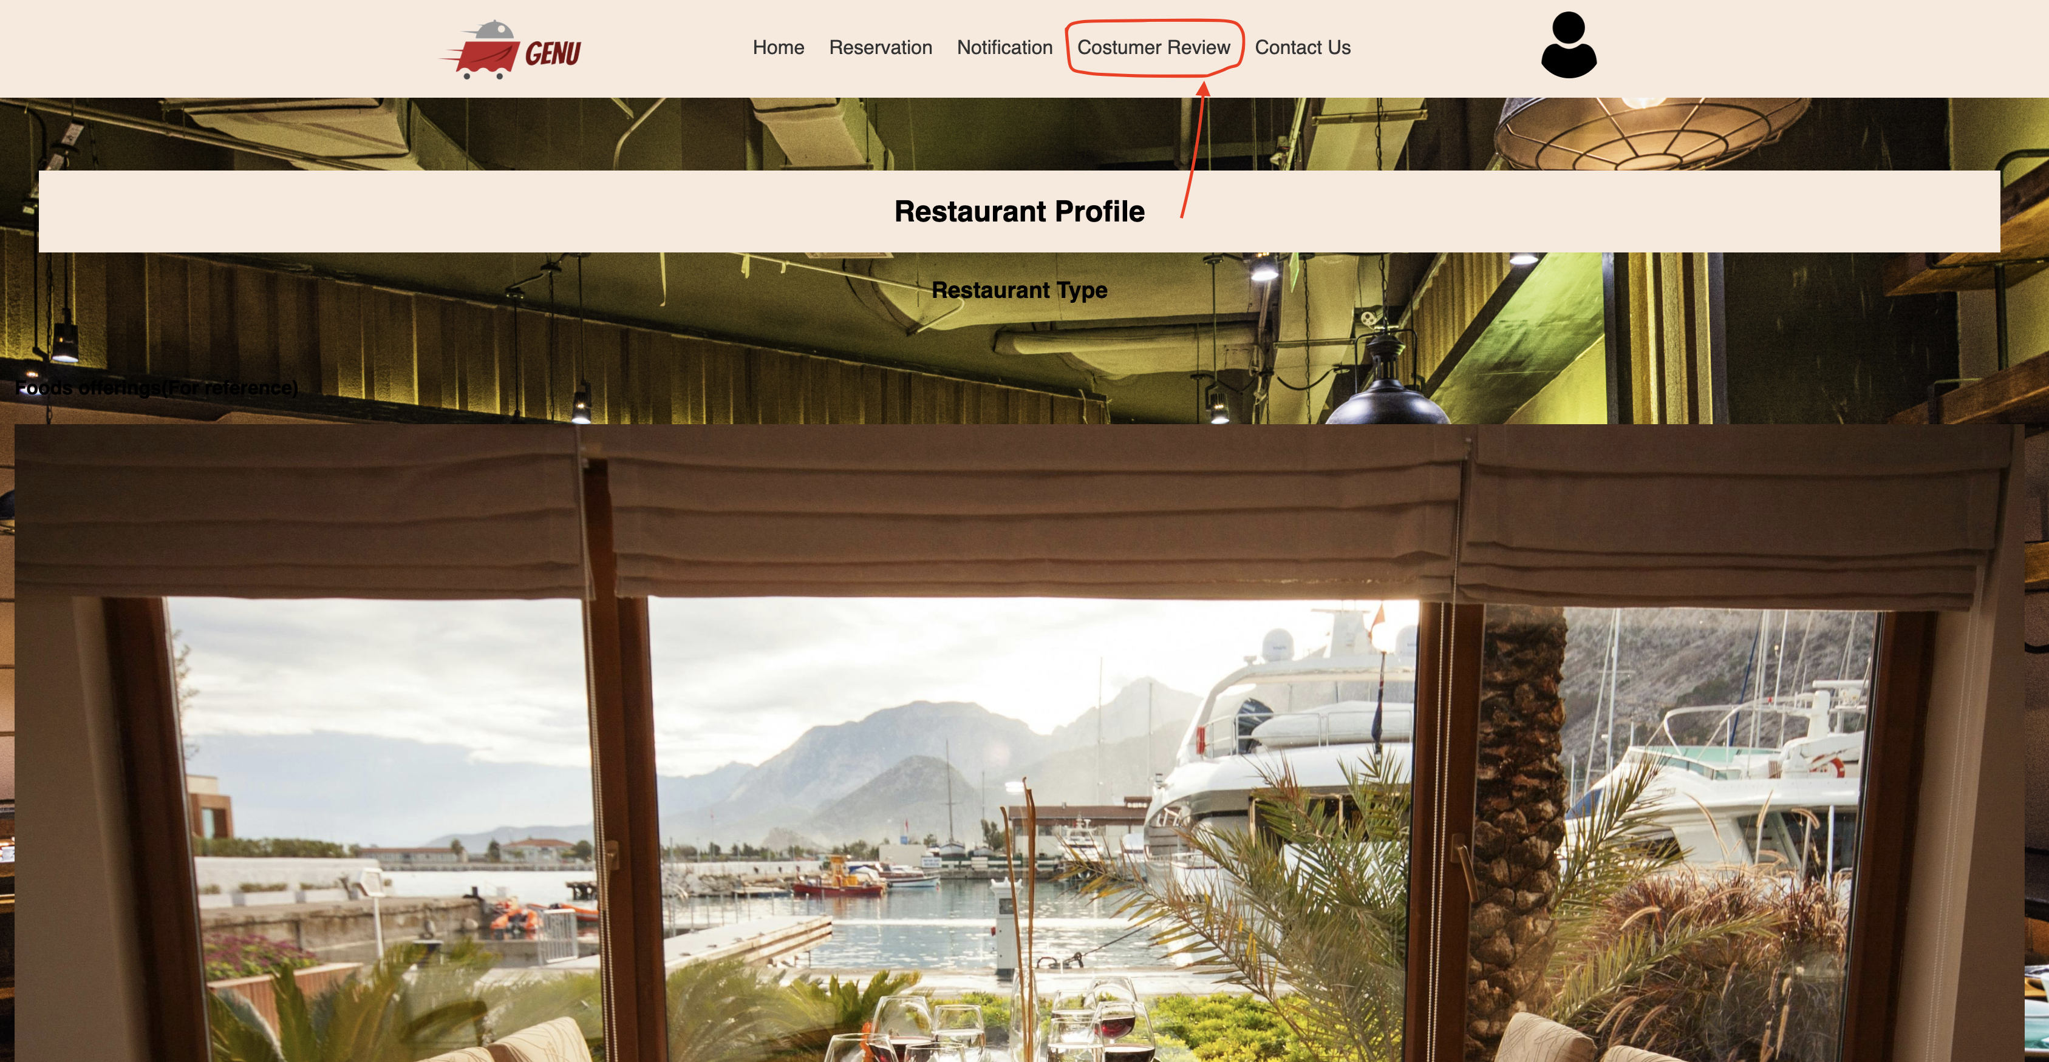

Figure 2: Read Customer Review

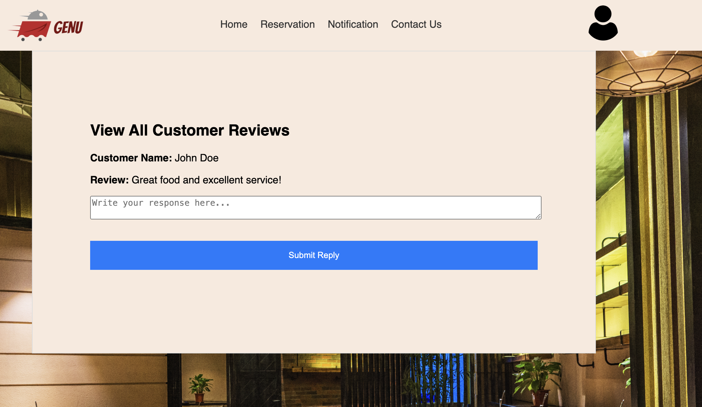

Figure 3: Respond to Review

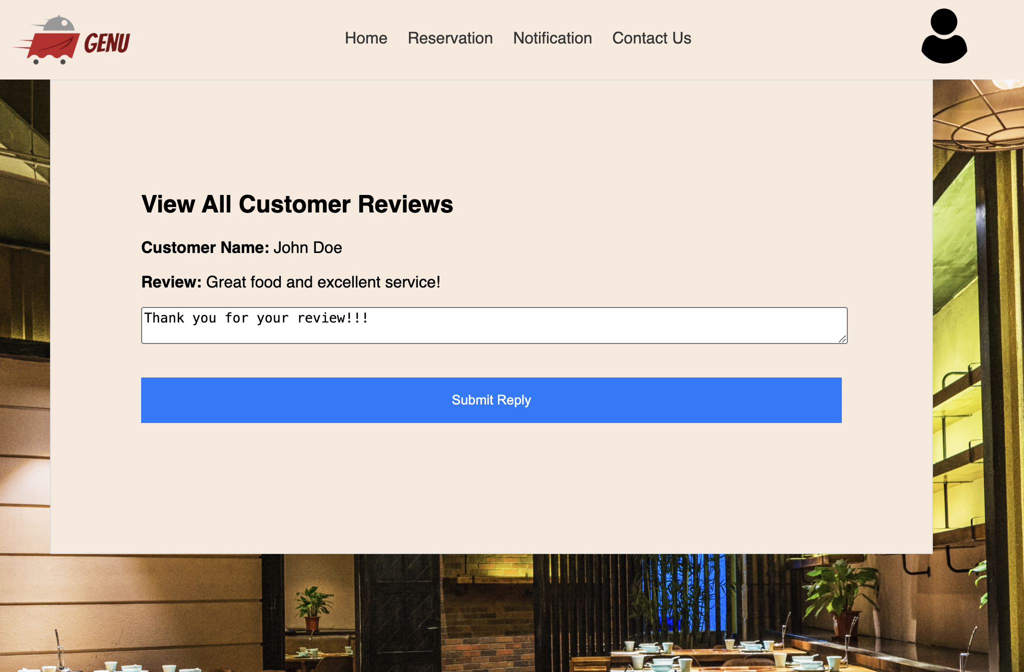

## 8.3 System Administration Scenario: Managing User Access

**Assumption:** The Sysadmin is logged in and on the user management page.

**Steps:**

1. Sysadmin navigates to the user management section.
2. Sysadmin views the list of users.
3. Sysadmin updates access rights.

Figure 1: User Management

